**Chapter 3**

**Data set**

**3.1 American Sign Language**

American sign language [13] is used to communicate between deaf community and normal community. However, there are only 2.5 million ~ 5.0 million who speak sign language which significantly limits the number of people they can easily communicate with [12].

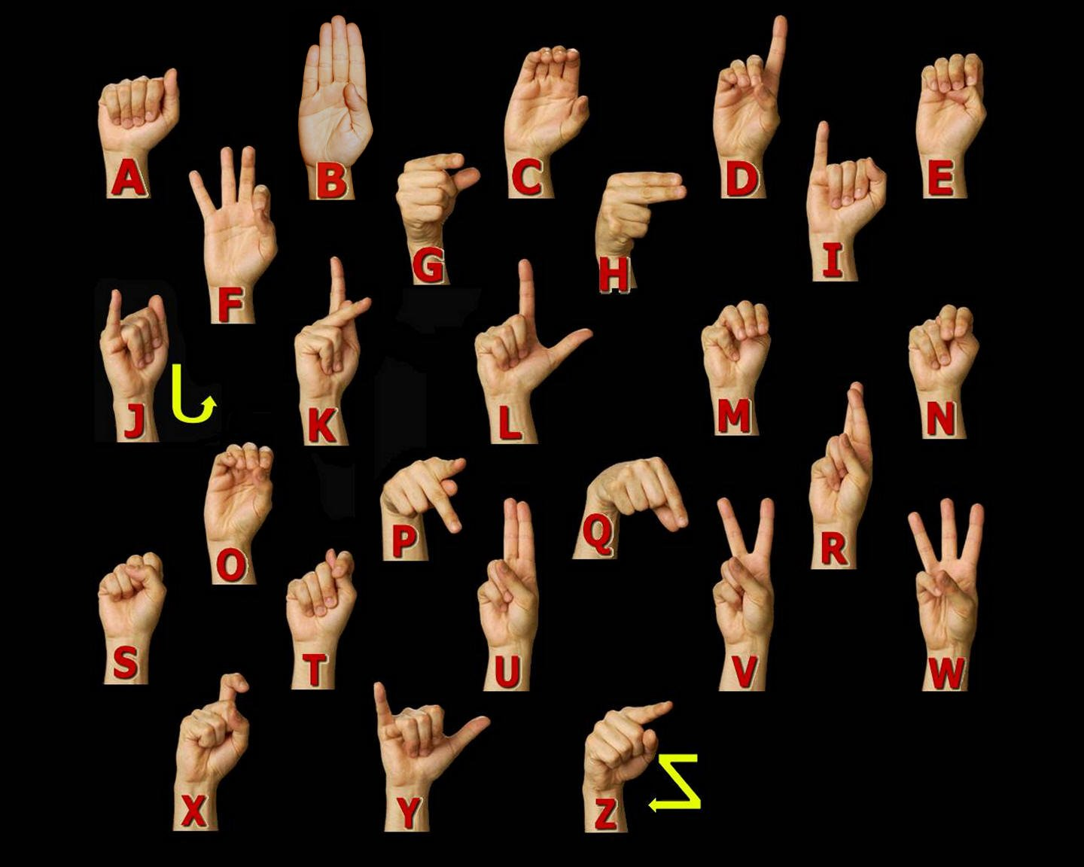

**American Sign language Manual Alphabet [13].**

American Sign Language is implemented from French sign language which was introduced by Thomas Hopins Gallaudet in United States [?]. ASL is similar to French sign language; individuals who speak American Sign Language are able to effectively communicate in French Sign Language. A variation of American Sign Language exits as there are variations between English spoken in England, United States or Australia, there are differences in their sign languages [12].

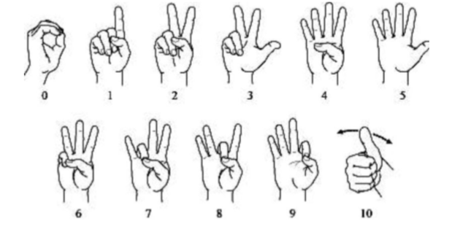

**Figure 1. American Sign language numbers. [13]**

**3.2 Characteristics of American Sign Language**

* American Sign language is an entire visual-gestural dialect with its very own language structure, vocabulary, and linguistic structure.
* Like other sign languages, it utilizes the hands, the body, and face looks (counting mouth developments) to express significance and the eyes to see meaning.
* Hand - to-hand connection is especially critical in ASL since it has no composed frame. There are in any case, documentation frameworks that are utilized for recording signs on paper.
* ASL is separate from English and is unique from other sign languages. An example of the distinctiveness of sign languages from each other and from the surrounding spoken language(s) is that, although English is the shared spoken language of the U.S., Canada, and Britain, signers of ASL do not understand signers of British Sign Language (BSL).

**3.3. Statistics** **about sign language use in Canada**

In Canada, Statistics Canada reports that as indicated by the 2006 Census 8,995 people revealed a gesture-based communication just like their primary language or one of their first languages, as given below.

**Table 1: Statics about Sign Language as a Mother Tongue [14]**

|  |  |
| --- | --- |
| American Sign Language | 2,485 |
| Quebec Sign Language | 730 |
| Sign languages, not included elsewhere | 5,780 |

In addition, Statistics Canada reports that as per the 2006 Census 43,090 people reported knowledge of a gesture-based communication, as provided below.

**Table 2: Statics about Knowledge of Sign Languages[14]**

|  |  |
| --- | --- |
| American Sign Language | 11,110 |
| Quebec Sign Language | 730 |
| Sign languages, not included elsewhere | 5,780 |

**3.4 Dataset and variables**

I have created my own data set. This dataset was a collection of 36 characters which contain A to Z alphabets and 0 to 9 number digits. I used right hand to capture 1200 images for specific alphabets and numbers. Code was implemented to convert flip images from right to left hand image. The height and width ratios vary significantly but average approximately 50X50 pixels. The dataset contains over 100,000 images in grey scale color. Additionally, people can add their images to this dataset. Below figure shows an image of A to Z alphabet.

|  |  |  |  |
| --- | --- | --- | --- |
|  | **A** |  | **N** |
|  | **B** |  | **O** |
|  | **C** |  | **P** |
|  | **D** |  | **Q** |
|  | **E** |  | **R** |
|  | **F** |  | **S** |
|  | **G** |  | **T** |
|  | **H** |  | **U** |
|  | **I** |  | **V** |
|  | **J** |  | **W** |
|  | **K** |  | **X** |
|  | **L** |  | **Y** |
|  | **M** |  | **Z** |

**Figure 2: Data set images.**

|  |  |
| --- | --- |
| **Property** | **Description** |
| Alphabets | A to Z |
| Numbers | 0 to 9 |
| Color | Grey Scale |
| Dimensions | 50x50 |
| Height | 50 pixels |
| Width | 50 pixels |
| File type | JPEG |

**Table 3: Dataset Description and Image property**

**3.5 Capturing Images for Dataset**

To detect hand gestures using skin colour there are different approaches including skin colour-based methods.In this thesis, after detecting and subtracting the face and other background, skin recognition and a contour comparison algorithm were used to search for the hand and discard other background colour objects for every frame captured from a webcam or video file.Palm to extract their contours and saved the four for evaluation with the contours of the skin detected area of every frame.After detecting the skin area for each frame captured, contours of the detected areas were compared with the previously saved hand histogram template contours to remove other skin like objects existing in the image.If the contour comparison of the spotted skin area complies with any one of the saved hand histogram contours, then it captured hand gesture only. I have explained more information about my approach to hand detection in chapter 4.